
Symbiosis Institute of Technology, Pune
Faculty of Engineering
CSE- Academic Year 2026-27
Java Programming – Lab Batch 2025-29
Lab Assignment No:- 26
Name of Student | Aarushi Raizada
PRN No. | 25070122002
Batch | 2025-29
Class | A1
Academic Year & Semester | 2026 SEM III
Date of Submission | 17/10/26
Title of Assignment: | Write a Java program to create and execute multiple threads using the Runnable interface
Theory  Practice questions | Theory  The Runnable interface provides an alternative approach to creating threads in Java. A class  implementing Runnable defines the run() method that contains the code executed by the thread. The  Runnable object is passed to a Thread object, which starts execution using the start() method. Unlike  extending the Thread class, implementing Runnable allows a class to inherit from another  superclass, making the design more flexible. Runnable separates task definition from thread  execution, resulting in better code organization and reusability. It is widely used in multithreaded  enterprise applications and thread pool implementations.  1. Create a program using Runnable to run two tasks simultaneously.  class Task1 implements Runnable {  public void run() {  for (int i = 1; i <= 5; i++) {  System.out.println("Task 1: " + i);  }  }  }  class Task2 implements Runnable {  public void run() {  for (int i = 1; i <= 5; i++) {  System.out.println("Task 2: " + i);  }  }  }  public class Run {  public static void main(String[] args) {  Task1 t1 = new Task1();  Task2 t2 = new Task2();  Thread th1 = new Thread(t1);  Thread th2 = new Thread(t2);  th1.start();  th2.start();  }  }  }  2. Create a Java program using the Runnable interface where two tasks run simultaneously: one thread  performs deposit operations, and another performs withdrawal operations, both displaying results  concurrently..  class BankAccount {  int balance = 1000;  synchronized void deposit(int amount) {  balance += amount;  System.out.println("Deposited: " + amount);  System.out.println("Balance: " + balance);  }  synchronized void withdraw(int amount) {  if (balance >= amount) {  balance -= amount;  System.out.println("Withdrawn: " + amount);  } else {  System.out.println("Insufficient balance!");  }  System.out.println("Balance: " + balance);  }  }  class DepositTask implements Runnable {  BankAccount account;  DepositTask(BankAccount account) {  this.account = account;  }  public void run() {  for (int i = 1; i <= 3; i++) {  account.deposit(500);  }  }  }  class WithdrawTask implements Runnable {  BankAccount account;  WithdrawTask(BankAccount account) {  this.account = account;  }  public void run() {  for (int i = 1; i <= 3; i++) {  account.withdraw(300);  }  }  }  public class BankAcc {  public static void main(String[] args) {  BankAccount account = new BankAccount();  Thread t1 = new Thread(new DepositTask(account));  Thread t2 = new Thread(new WithdrawTask(account));  t1.start();  t2.start();  }  }
Output Screenshots (if applicable) | Ans 1  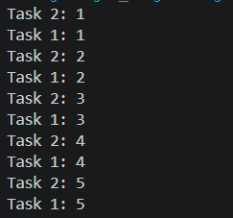  Ans 2  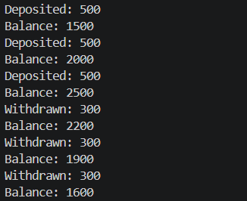
Conclusion | Successfully implemented concurrent deposit and withdrawal operations using the Runnable interface and synchronized methods to maintain a consistent account balance.

